1. **Search for the Catalog Pocket App**

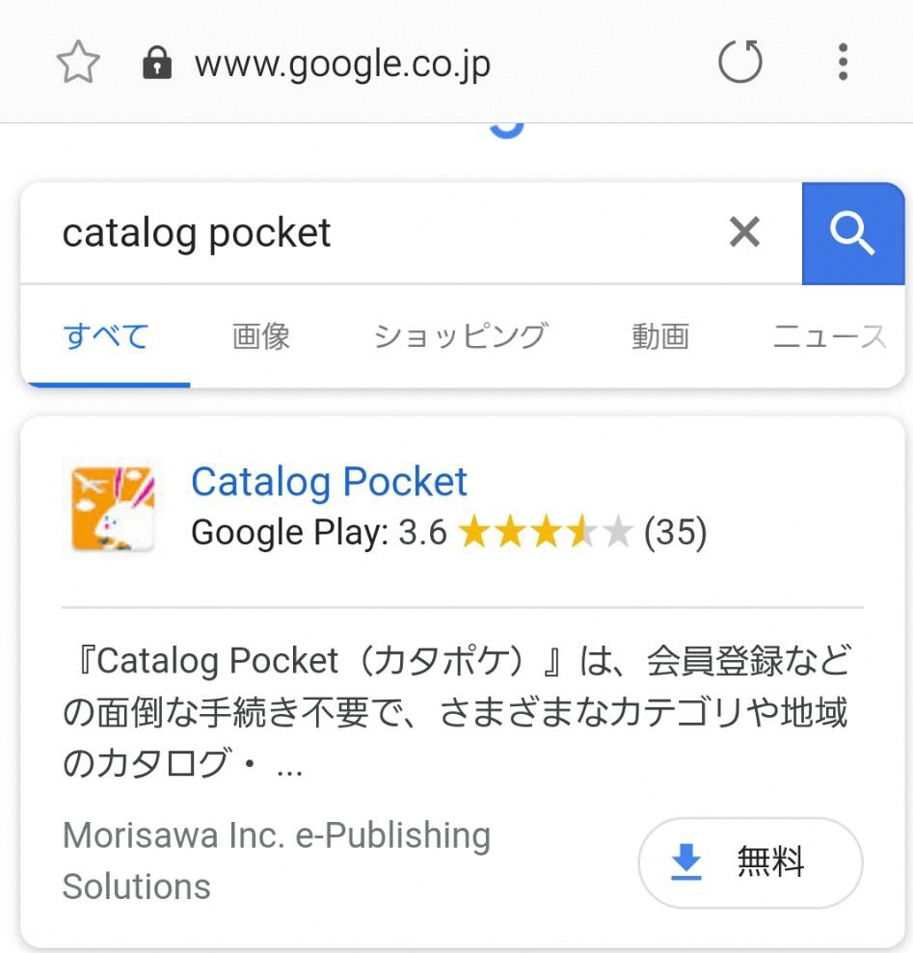

Enter “Catalog Pocket” on a search engine of a smartphone or tablet.

Click on Free

1. **Download App**

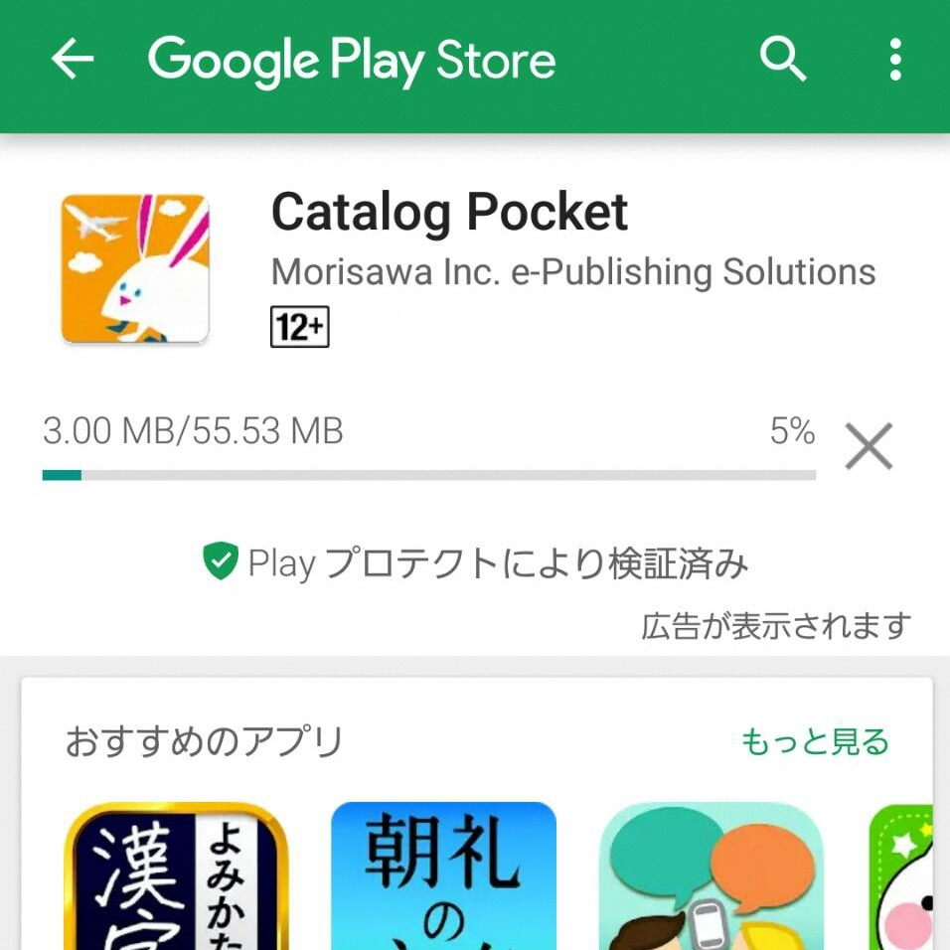

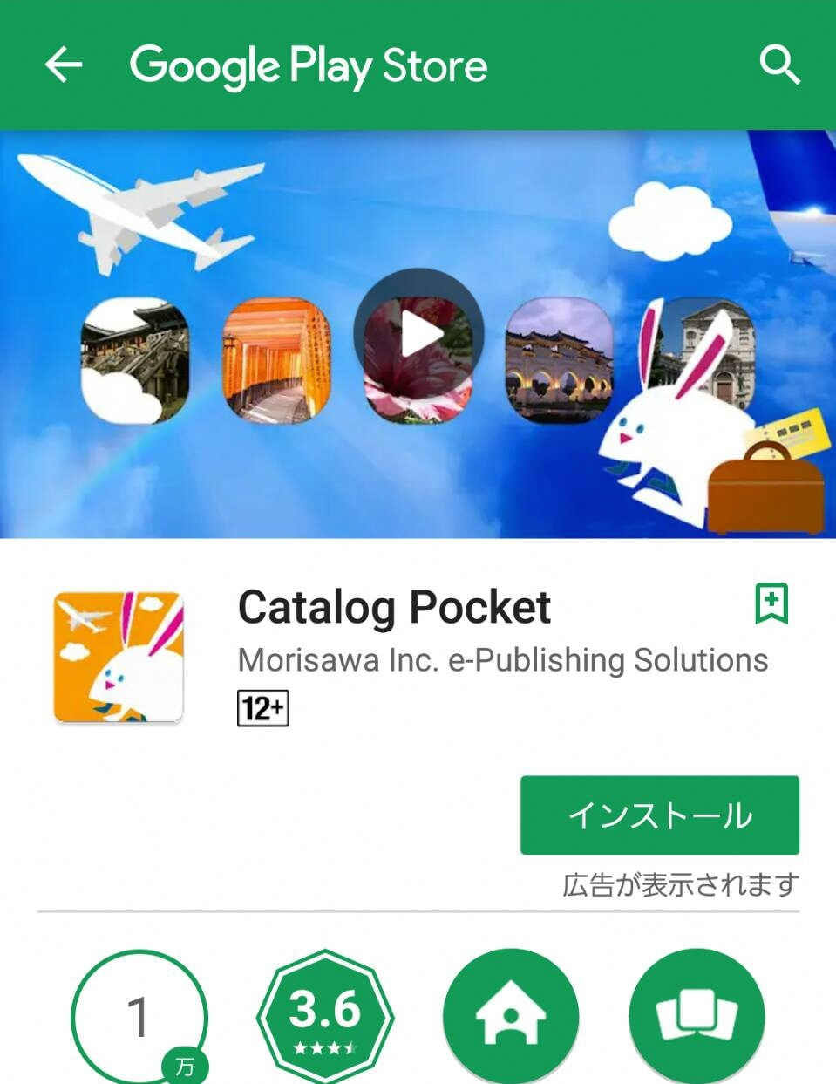

Click on “Install”

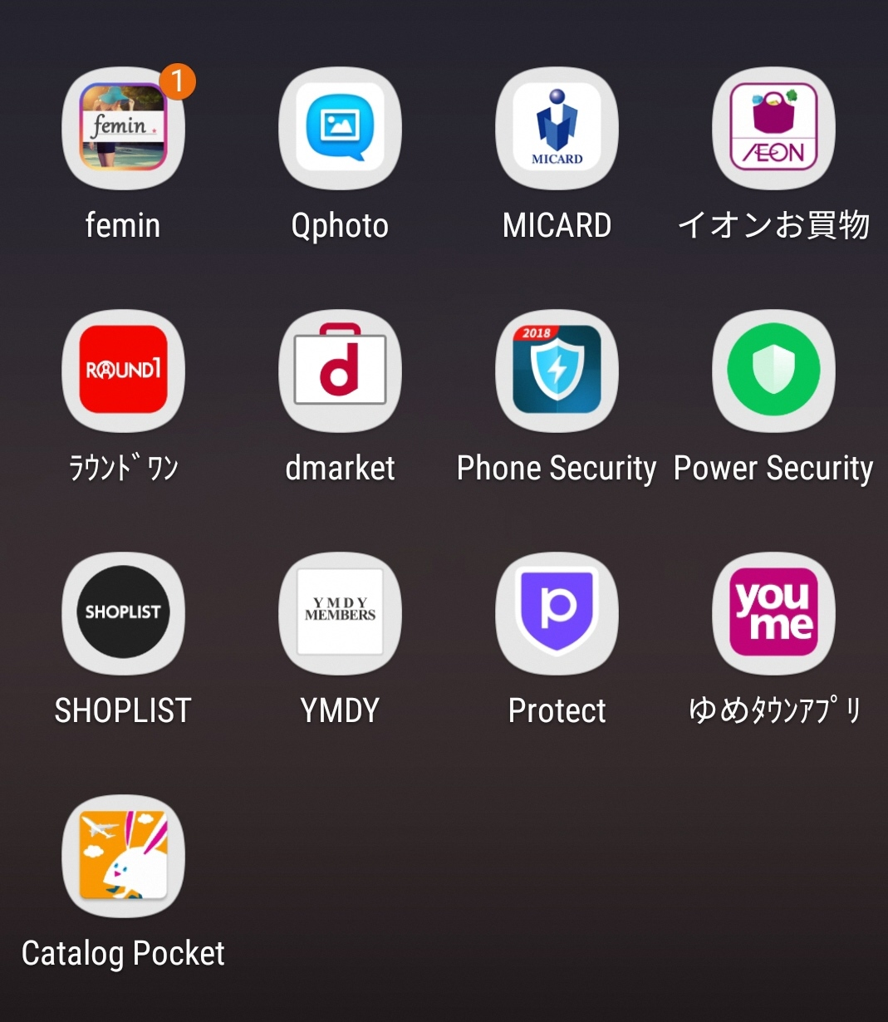

1. **Opening the App**

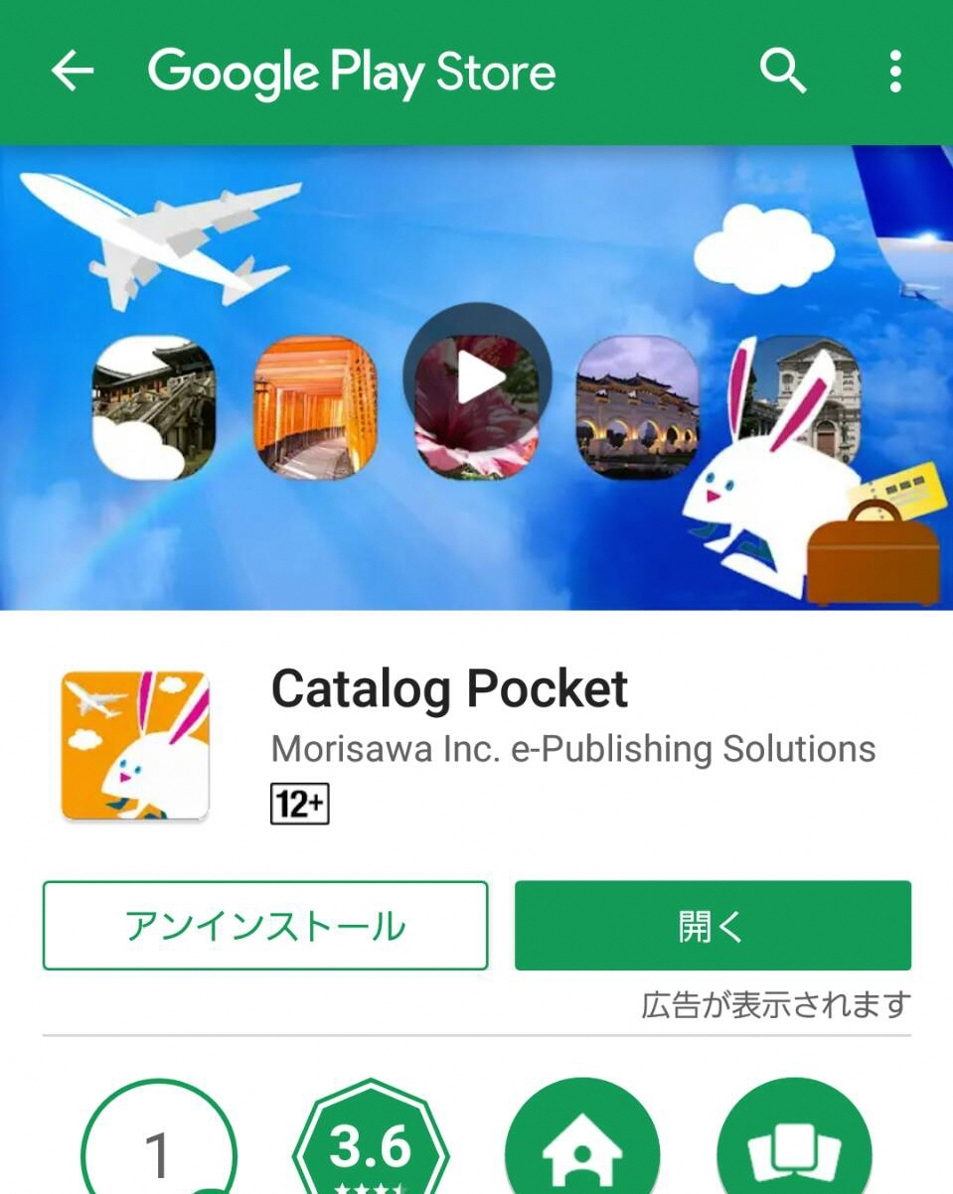

Click on the downloaded app

Click on “Open”

*If you click on “Open”, go to 5 (Look for 「広報たかまつ」 [*Koho Takamatsu*]).

*Open after download.

1. **Start after Accepting Terms**

Click on the “Skip” button





After accepting Terms, click on the “Start” button

1. **Look for 「広報たかまつ」 [*Koho Takamatsu*]**

Click on “Search”

Open the menu

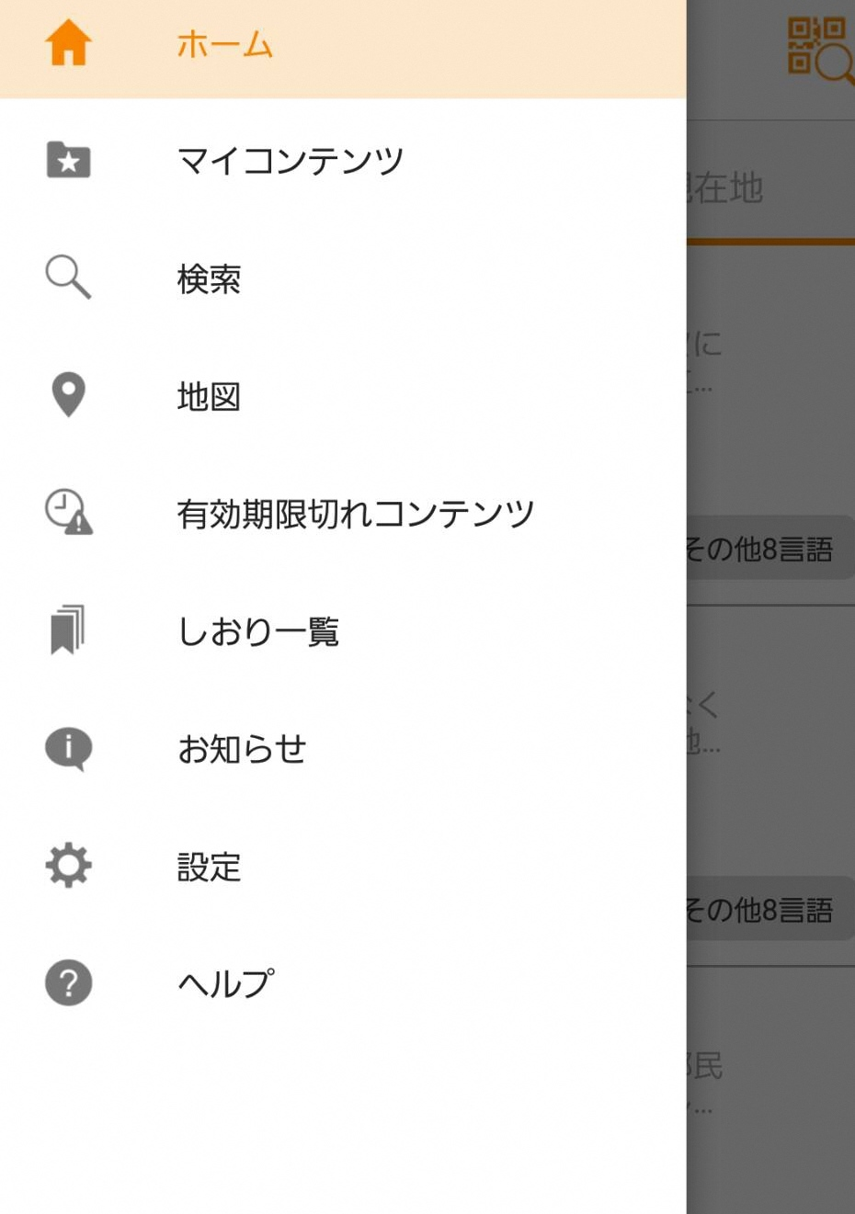

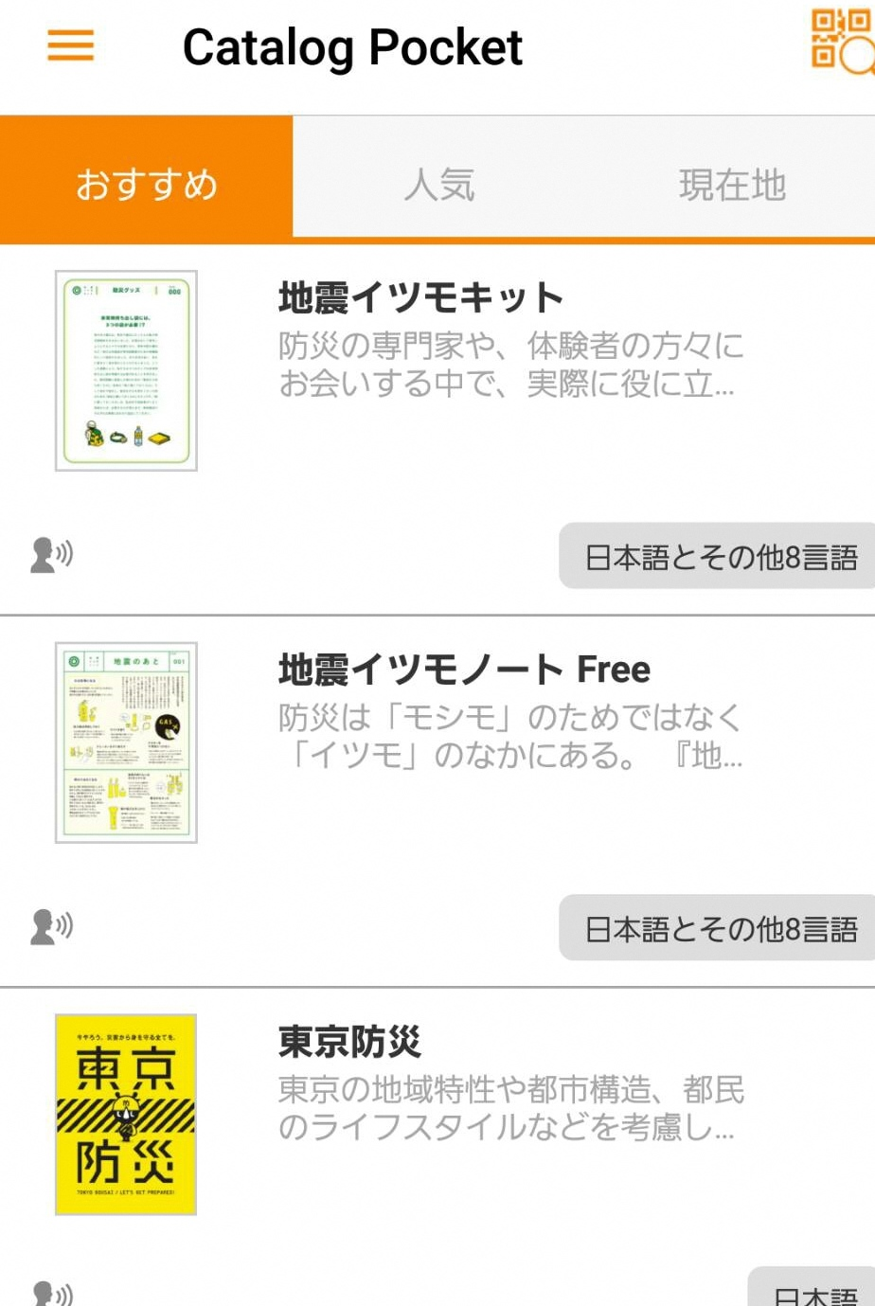

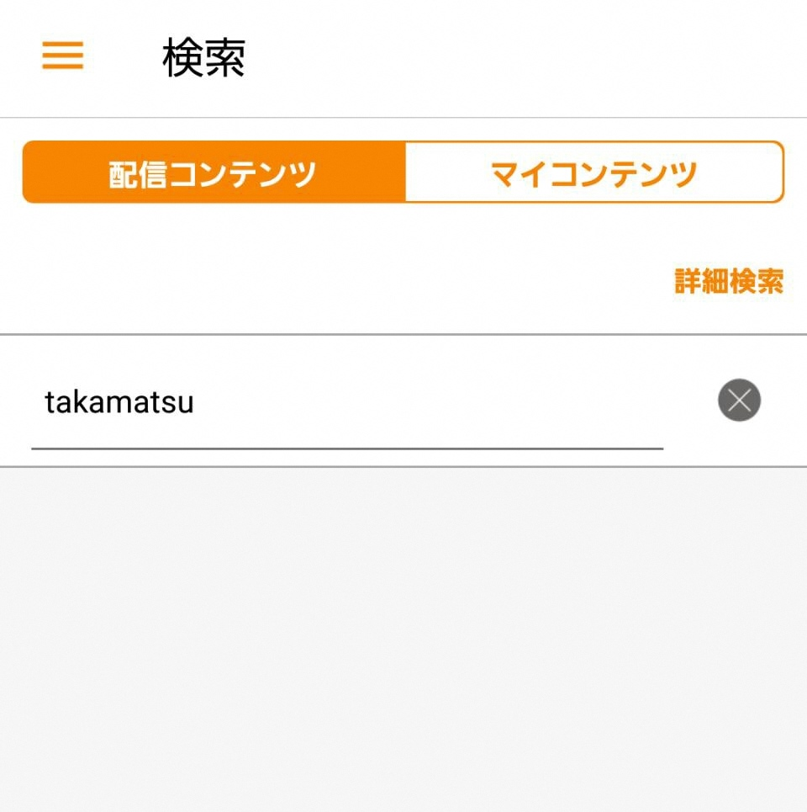

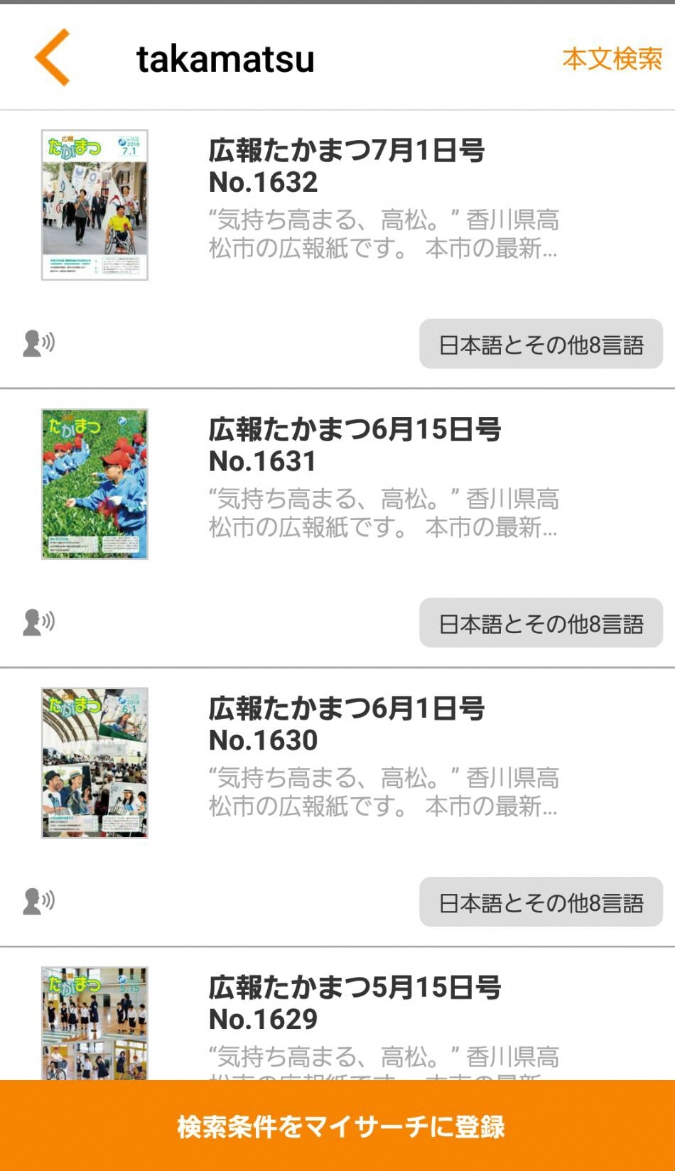

Enter “Takamatsu”

Select an issue of your choice

1. **Select Language and read 「広報たかまつ」 [*Koho Takamatsu*]**



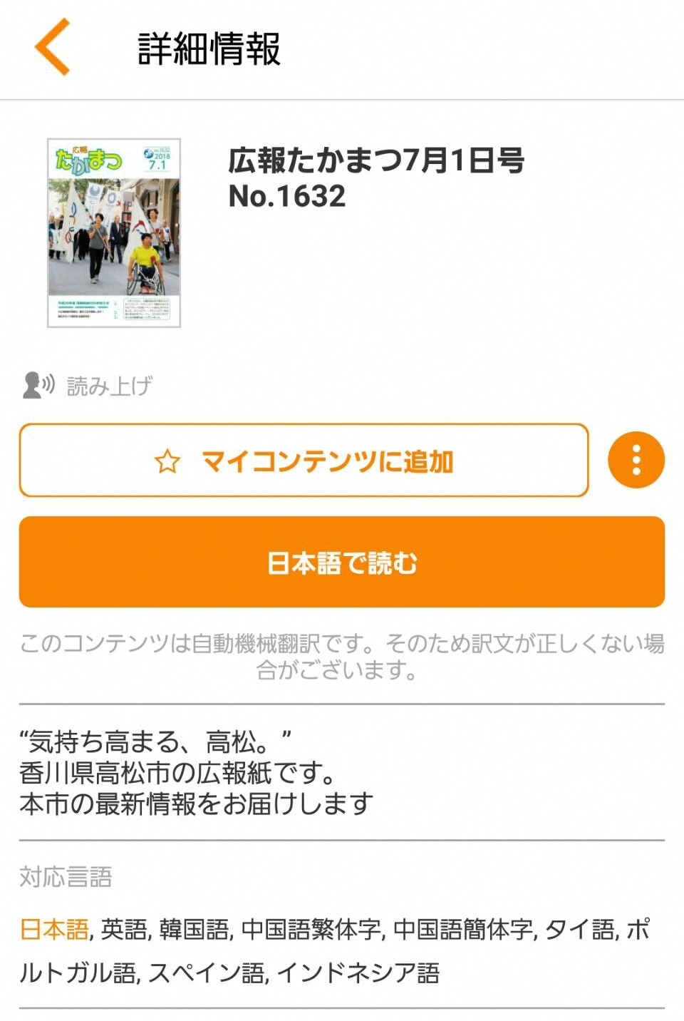

Select and click on the language (in yellow) of your choice.

Touch where you want to read and the language will be translated.